
Progressive Education Society's
Modern College of Engineering, Pune
MCA Department
A.Y.2023-24
410906: Web Technologies Lab
**********************************************************************************************
Class: SY-MCA Shift / Div : A Batch: S3 Roll Number : 52062

Name: Pratiksha Sonawane Assignment No : 6 Date of Implementation :
**********************************************************************************************

Q1. Design a Registration form Default.aspx page with fields Username, choose
password, confirm password, age, email id, city and a submit button.

Code:
(index.cshtml)
@{
ViewData["Title"] = "Home Page";
}
<div class="container mt-4">
<h2>Registration Form</h2>
<form asp-action="Register" method="post">
<div class="form-group">
<label for="username">Username:</label>
<input type="text" class="form-control" id="username" name="username">
</div>
<div class="form-group">
<label for="password">Password:</label>
<input type="password" class="form-control" id="password" name="password">
</div>
<div class="form-group">
<label for="confirmPassword">Confirm Password:</label>
<input type="password" class="form-control" id="confirmPassword" name="confirmPassword">
</div>
<div class="form-group">
<label for="age">Age:</label>
<input type="number" class="form-control" id="age" name="age">
</div>
<div class="form-group">
<label for="email">Email:</label>
<input type="email" class="form-control" id="email" name="email">
</div>
<div class="form-group">
<label for="city">City:</label>
<input type="text" class="form-control" id="city" name="city">
</div><br>
<button type="submit" class="btn btn-primary">Submit</button>
</form>

@if (ViewData["Message"] != null)
{
<div class="mt-4">
<h3>Registration Details</h3>
<p>@ViewData["Message"]</p>
</div>
}
</div>

(_Layout.cshtml)
<!DOCTYPE html>
<html lang="en">
<head>
<meta charset="utf-8" />
<meta name="viewport" content="width=device-width, initial-scale=1.0" />
<title>@ViewData["Title"] - WebApplication1</title>
<link rel="stylesheet" href="~/lib/bootstrap/dist/css/bootstrap.min.css" />
<link rel="stylesheet" href="~/css/site.css" asp-append-version="true" />
<link rel="stylesheet" href="~/WebApplication1.styles.css" asp-append-version="true" />
</head>
<body>
<header>
</header>
<div class="container">
<main role="main" class="pb-3">
@RenderBody()
</main>
</div>
<script src="~/lib/jquery/dist/jquery.min.js"></script>
<script src="~/lib/bootstrap/dist/js/bootstrap.bundle.min.js"></script>
<script src="~/js/site.js" asp-append-version="true"></script>
@await RenderSectionAsync("Scripts", required: false)
</body>
</html>

(HomeController)
using Microsoft.AspNetCore.Mvc;

public class HomeController : Controller
{
public IActionResult Index()
{
return View();
}

[HttpPost]
public IActionResult Register(string username, string password, string confirmPassword, int age, string email, string city)
{
string message = $"Username: {username}\nPassword: {password}\nAge: {age}\nEmail: {email}\nCity: {city}";
ViewData["Message"] = message;

return View("Index");
}
}

Output:
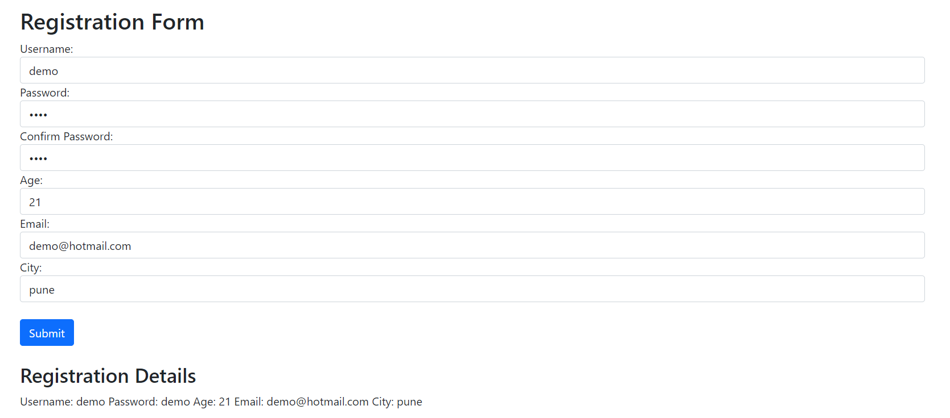

Q2.Write a Client side script to use CustomValidator control (Use JavaScript)
Code:
(JS Snippet)
<script>
function validateForm() {
clearErrorMessages();

var isValid = true;
var username = document.getElementById("username").value;
if (username === "") {
document.getElementById("usernameError").innerText = "Username is required";
isValid = false;
}
var password = document.getElementById("password").value;
if (password === "") {
document.getElementById("passwordError").innerText = "Password is required";
isValid = false;
}
var confirmPassword = document.getElementById("confirmPassword").value;
if (confirmPassword === "") {
document.getElementById("confirmPasswordError").innerText = "Confirm Password is required";
isValid = false;
}
var age = document.getElementById("age").value;
if (age === "") {
document.getElementById("ageError").innerText = "Age is required";
isValid = false;
}
var email = document.getElementById("email").value;
if (email === "") {
document.getElementById("emailError").innerText = "Email is required";
isValid = false;
}

var city = document.getElementById("city").value;
if (city === "") {
document.getElementById("cityError").innerText = "City is required";
isValid = false;
}

return isValid;
}

function clearErrorMessages() {
var errorElements = document.querySelectorAll(".text-danger");
errorElements.forEach(function (element) {
element.innerText = "";
});
}
</script>

Output:
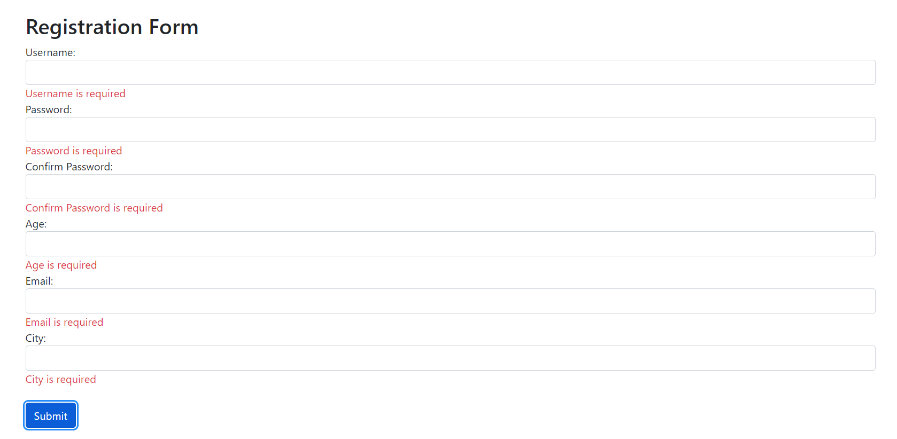
Q3.Create ASP.NET application to store and retrieve values in database (Use Employee database having fields E-Id, EName, Contact No., Department,Salary)
Code:
(index.cshtml)

@{
ViewData["Title"] = "Home Page";
}

<div class="container mt-4">
<table class="table">
<thead>
<tr>
<th>E-Id</th>
<th>EName</th>
<th>Contact No.</th>
<th>Department</th>
<th>Salary</th>
</tr>
</thead>
<tbody>
@foreach (var employee in Model)
{
<tr>
<td>@employee.EId</td>
<td>@employee.EName</td>
<td>@employee.ContactNo</td>
<td>@employee.Department</td>
<td>@employee.Salary</td>
</tr>
}
</tbody>
</table>

<div class="text-center">
<h1 class="display-4">Welcome</h1>
<p>
Learn about
<a href="https://docs.microsoft.com/aspnet/core">building Web apps with ASP.NET Core</a>.
</p>
</div>
</div>

(HomeController.cs)
using Microsoft.AspNetCore.Mvc;
using Microsoft.Extensions.Logging;
using System.Diagnostics;
using System.Collections.Generic;
using WebApplication2.Models;

namespace WebApplication2.Controllers
{
public class HomeController : Controller
{
private readonly ILogger<HomeController> _logger;

public HomeController(ILogger<HomeController> logger)
{
_logger = logger;
}

public IActionResult Index()
{

List<Employee> employees = GetEmployeesFromDatabase();

return View(employees);
}

private List<Employee> GetEmployeesFromDatabase()
{

return new List<Employee>
{
new Employee { EId = 1, EName = "John Doe", ContactNo = "1234567890", Department = "IT", Salary = 50000 },
new Employee { EId = 2, EName = "Jane Smith", ContactNo = "9876543210", Department = "HR", Salary = 60000 }

};
}

public IActionResult Privacy()
{
return View();
}

[ResponseCache(Duration = 0, Location = ResponseCacheLocation.None, NoStore = true)]
public IActionResult Error()
{
return View(new ErrorViewModel { RequestId = Activity.Current?.Id ?? HttpContext.TraceIdentifier });
}

public IActionResult Contact()
{
return View();
}

public IActionResult About()
{
return View();
}
}
}
(appsettings.json)
{
"Logging": {
"LogLevel": {
"Default": "Information",
"Microsoft.AspNetCore": "Warning"
}
},
"AllowedHosts": "*",
"ConnectionStrings": {
"DefaultConnection": "Server=localhost;Port=3306;Database=EmployeeDb;User=root;Password=;MultipleActiveResultSets=true"
}
}

(AppDbContext.cs)
using Microsoft.EntityFrameworkCore;

public class AppDbContext : DbContext
{
public AppDbContext(DbContextOptions<AppDbContext> options) : base(options)
{
}

public DbSet<Employee> Employees { get; set; }

protected override void OnModelCreating(ModelBuilder modelBuilder)
{
modelBuilder.Entity<Employee>(entity =>
{
entity.ToTable("emp");
entity.HasKey(e => e.EId);
});
}
}

(Employee.cs)
public class Employee
{
public int EId { get; set; }
public string EName { get; set; }
public string ContactNo { get; set; }
public string Department { get; set; }
public decimal Salary { get; set; }
}

Output:
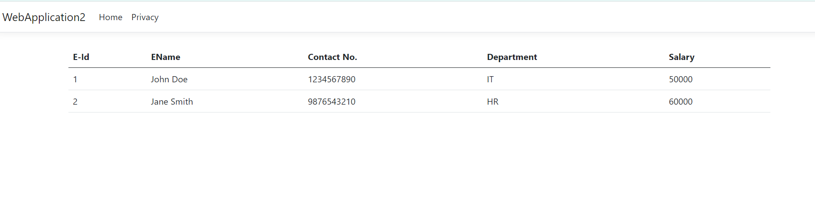
Database
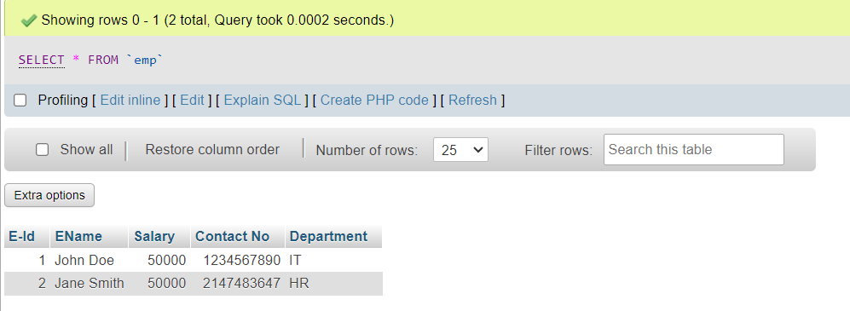

Q5.Create login form in ASP.NET with database connectivity
Code:
(HomeController.cs)
using Microsoft.AspNetCore.Mvc;
using Microsoft.Extensions.Logging;
using loginpage.Models;
namespace loginpage.Controllers
{
public class HomeController : Controller
{
private readonly ILogger<HomeController> _logger;
private readonly AppDbContext _context;

public HomeController(ILogger<HomeController> logger, AppDbContext context)
{
_logger = logger;
_context = context;
}

public IActionResult Index()
{
return View();
}

[HttpGet]
public IActionResult Login()
{
return View();
}

[HttpPost]
public IActionResult Login(LoginViewModel model)
{

return RedirectToAction("Index");
}
}
}

(AppDbContext.cs)
using Microsoft.EntityFrameworkCore;

public class AppDbContext : DbContext
{
public DbSet<User> Users { get; set; }

public AppDbContext(DbContextOptions<AppDbContext> options) : base(options)
{
}
}

(LoginViewModel.cs)
public class LoginViewModel
{
public string Username { get; set; }
public string Password { get; set; }
}

(User.cs)
public class User
{
public int Id { get; set; }
public string Username { get; set; }
public string Password { get; set; }
}
(Login.cshtml)
@model LoginViewModel

<form asp-action="Login" method="post">
<label asp-for="Username">Username:</label>
<input asp-for="Username" />

<label asp-for="Password">Password:</label>
<input asp-for="Password" type="password" />

<button type="submit">Login</button>
</form>

(appsettings.json)
{
"Logging": {
"LogLevel": {
"Default": "Information",
"Microsoft.AspNetCore": "Warning"
}
},
"AllowedHosts": "*",
"ConnectionStrings": {
"DefaultConnection": "Server=localhost;Database=emp;User=root;Password=;Port=3306;"
}
}

(Startup.cs)

using Microsoft.EntityFrameworkCore;

static public void ConfigureServices(IServiceCollection services)
{
services.AddDbContext<AppDbContext>(options =>
options.UseMySql(Configuration.GetConnectionString("DefaultConnection")));
}

Output:
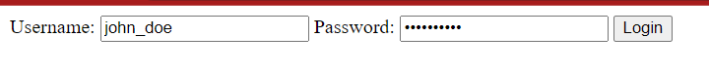
Database
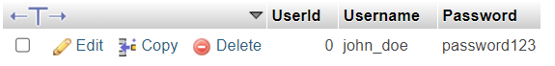

Q5.Create a Website in ASP.NET. The Web Site present weather data from the Weather station
Code:
(HomeController.cs)
using Microsoft.AspNetCore.Mvc;
using System.Threading.Tasks;
using WeatherApp.Models;
using WeatherApp.Services;

public class HomeController : Controller
{
private readonly WeatherService _weatherService;

public HomeController(WeatherService weatherService)
{
_weatherService = weatherService;
}

public IActionResult Index()
{
return View();
}

[HttpPost]
public async Task<IActionResult> GetWeather(string city)
{
var weatherData = await _weatherService.GetWeather(city);
return View("Weather", weatherData);
}
}

(WeatherModel.cs)
public class WeatherModel
{
public string City { get; set; }
public string Temperature { get; set; }

}

(WeatherService.cs)

using System.Net.Http;
using System.Threading.Tasks;
using Newtonsoft.Json;

public class WeatherService
{
private readonly HttpClient _httpClient;

public WeatherService(HttpClient httpClient)
{
_httpClient = httpClient;
}

public async Task<WeatherModel> GetWeather(string city)
{
var apiKey = "455b1cf8f3a7e7c14353afd45e61555a"; //for Security Reasons i'm hiding my apiKey
var apiUrl = $"https://api.openweathermap.org/data/2.5/weather?q={city}&appid={apiKey}&units=metric";

var response = await _httpClient.GetStringAsync(apiUrl);
return JsonConvert.DeserializeObject<WeatherModel>(response);
}}
(Startup.cs)
services.AddHttpClient<WeatherService>();

Output:
